

PROJECT REPORT



**Content**

1. Case Study -----------------------------Pg. 3
2. Definition of the Problem ----------Pg. 3
3. Requirements Analysis--------------Pg. 3
4. Architecture of Website ------------Pg. 3
5. Project Tracking

And Monitoring Activities---------Pg. 3

1. Documentation Section ------------Pg. 3
2. Source Code---------------------------Pg. 3
3. User Guide-----------------------------Pg. 3

**Case Study**

Education is a primary necessity for Parents/Guardians to be updated about their wards, progress is even more important. Students who fail in exams might not reveal their marks to their Parents/Guardians because of fear. Teachers too are overloaded with work, because of which it becomes difficult to remember each child’s academic progress. Also, students too must be kept aware about their score progress and marks required for passing External Exams. A Web portal to track all these is a solution.

**1. Definition of the Problem**

**Definition Of Problem**

We have designed and build a website named 'eStudiez' intended to track academic progress of a student. This system will allow various types of users such as Students, Parents/Guardians, and Teachers to view and track progress. Students who have fared poorly will be provided additional study resources via this portal to improve their future performance. This portal will also provide information regarding Revision classes that can help to boost performance. Each student’s progress can be viewed and tracked by Students themselves and their Parents/Guardians. Parents/Guardians can also send feedback to school faculty for improvement of anything.

**Requirement Analysis**

**Functional Requirements**

The portal will be designed as a Single-Page-Application and responsive Website with a set of pages and menus that represent choice of activities to be performed. The pages, menus, and other visual elements must be designed in a visually appealing manner with attractive fonts, colors, and animations. All of these should also be laid out in a responsive manner.

Following are the functional requirements of the portal:

**Menus and Web Page Functionality:**

**Welcome Message:**

The home page should accept first name from the user and display a personalized welcome message. At the top corner, the user's first name should be displayed for the entire duration that the portal is loaded. The home page must also accept category of user in the form of radio button selection. Based on selection, respective page and menus will be displayed. Refer the Sitemap section to see sample menus.

**For Students:**

Marks that they have scored in internal tests conducted by teachers will be displayed in a table. Academic Progress menu option will display the gradual progress in various tests across the year in the form of table data. Study Resources menu option should display a table containing links to external sites, Videos, and additional textbooks. Revision Classes menu option should display information pertaining to extra classes for revision purposes. © Aptech Limited 2022 Date and time of these classes can be displayed here. Helplines will display list of phone numbers that students can call in case they require general assistance.

**For Teachers:**

Teachers can update marks that students have scored in internal tests conducted. This can be done through a form. These marks will not be stored anywhere and will not reflect on the student page as that functionality is beyond the scope of the project.

Academic Progress menu option will enable teachers to update the gradual progress in various tests across the year. The data for this can be accepted via a form. Add Study Resources menu option should enable teachers to add links to external sites, and additional textbooks. Revision Classes Updating option should accept date and times for extra classes for revision purposes.

**For Parents/Guardians:**

They can view marks and academic progress of their wards. Helplines will display list of phone numbers that parents/guardians can call in case they require general assistance.

**Feedback and Contact Us**

These menu options have common functionality for all category of users regardless of whether they are students, teachers, or parents/guardians. Feedback menu option should enable users to provide their feedback about this portal through a feedback form.

Contact Us menu option should enable users to contact the creators of the portal. An email id can be displayed here for contact information.

Over and above this, the portal should implement following functionalities:

* Display a continuous scrolling ticker at the bottom of the page with current date, time, and location (hint: Use geolocation features of HTML5).
* Display a visitor count at the top right corner of the page beside a logo image.
* Menu options should change color on hover and also after clicking.
* Fade-in and fade-out options can be used for the menus.

**Non-Functional Requirements:**

There are several non-functional requirements that should be fulfilled by the Website, henceforth called the 'system'.

The system should be:

**Safe to use**: The system should not result in any malicious downloads or unnecessary file downloads.

**Accessible**: The system should have clear and legible fonts, user-interface elements, and navigation elements.

**User-friendly**: The system should be easy to navigate with clear menus and other elements and easy to understand. Operability: The system should operate in a reliably efficient manner.

**Performance**: The system should demonstrate high value of performance through speed and throughput. In simple terms, the system should be fast to load and page redirection should be smooth.

**Capacity**: The system should support large number of users.

**Availability**: The system should be available 24/7 with minimum down time.

**Compatibility:** The system should be compatible with latest browsers.

**Appointment**

This Web portal will be a responsive and visually appealing Website to be used by individuals (Students, Parents/Guardians, and Teachers).

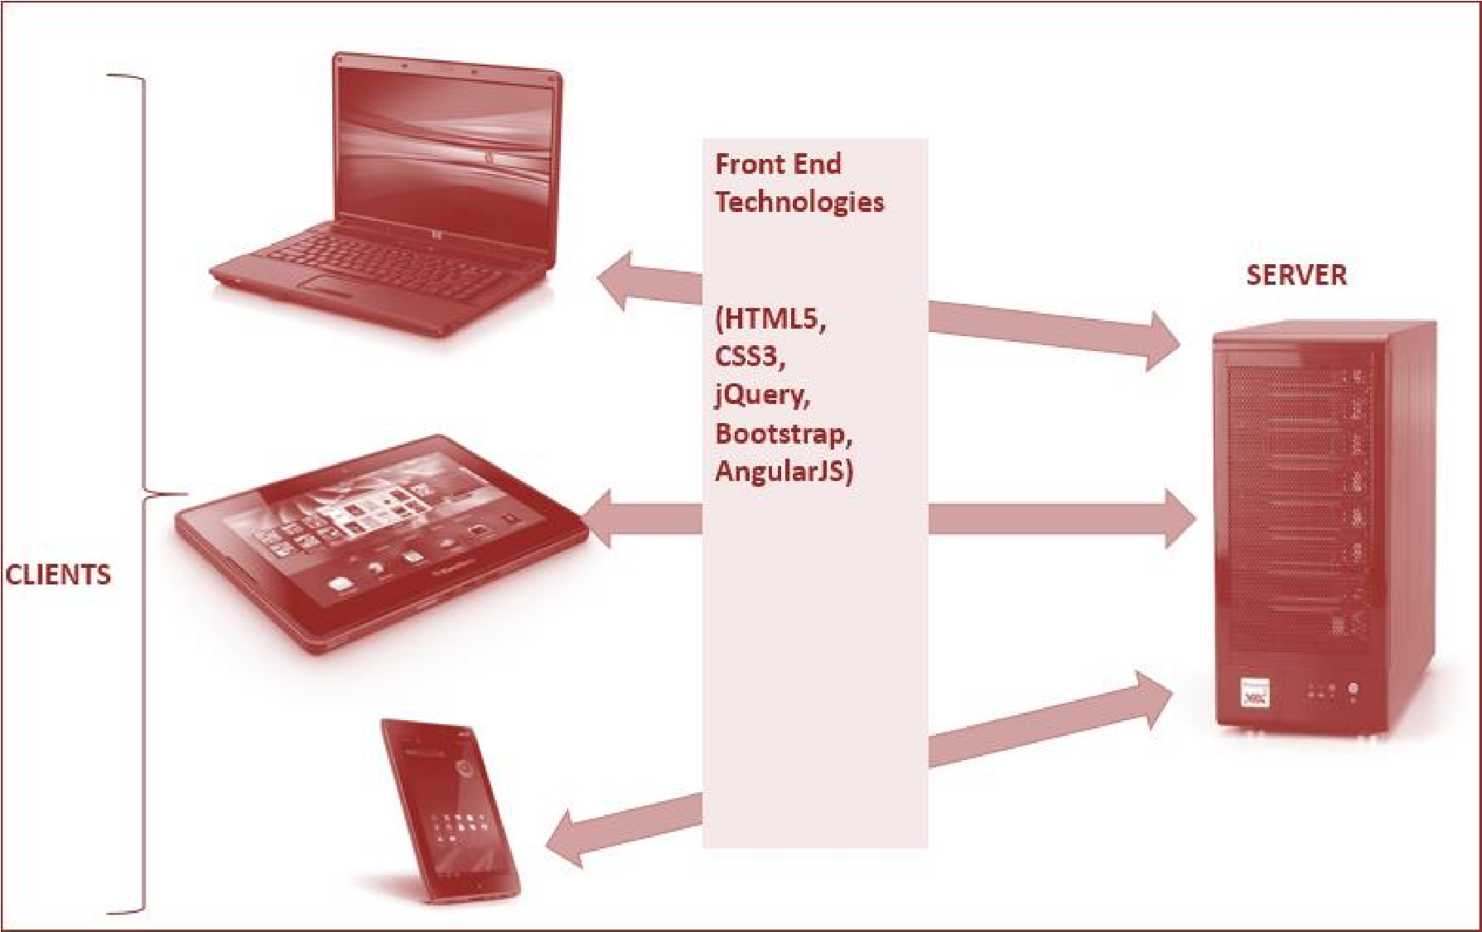**Architecture of Website**

**Site Map of Website**

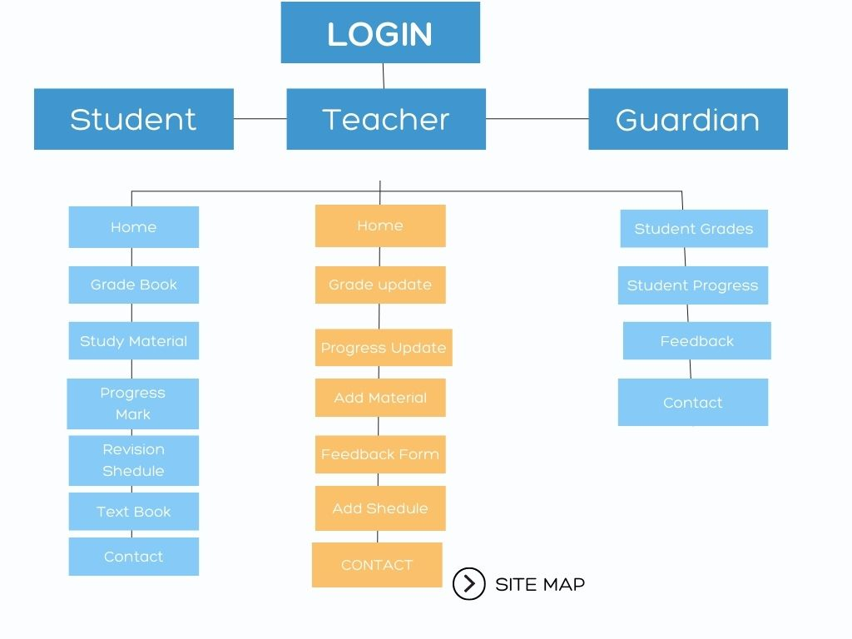

**Project Tracking and Monitoring**

**First Day**

We Have completed this website in 3 Days. In our first day we collected all the required information regarding the project and download all the images and necessary information related to website also we created layout of our 3 Sections Student, Guardians and teacher. We also developed Login Page and their connection to other section in our first day

**Second Day**

On Second Day we have developed all our JSON structure and it connections throughout the sections and with this we have also developed 2 sections of portal one was Student section and other one was Teacher section. We have also developed buttons and models of our portal

**Third Day**

On third day we developed our third and last page Guardians Page after completing all the sections with JSON connections we developed all the links between pages to fetch data from JSON. On same day we have developed routing of our sidebar and this was the final day of our project so we tested our website according to requirements.

**Source Code**

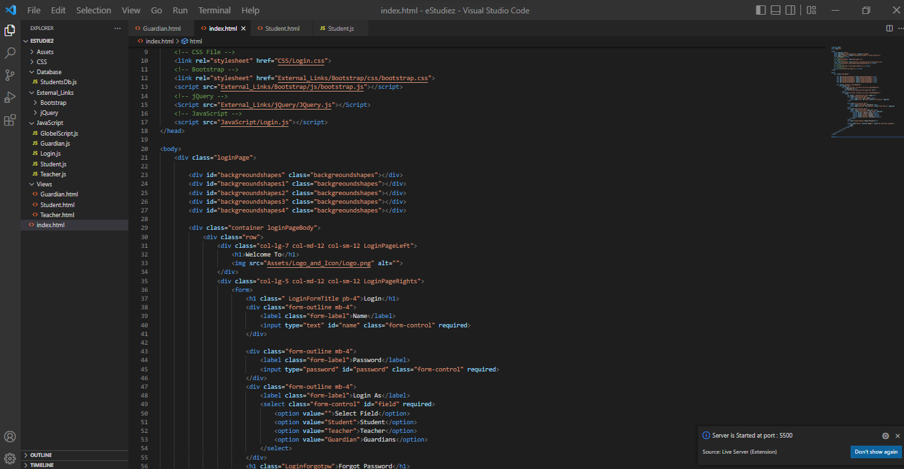

**User Guide**

**Login**

To use this portal first student have to Login with given student details via School.

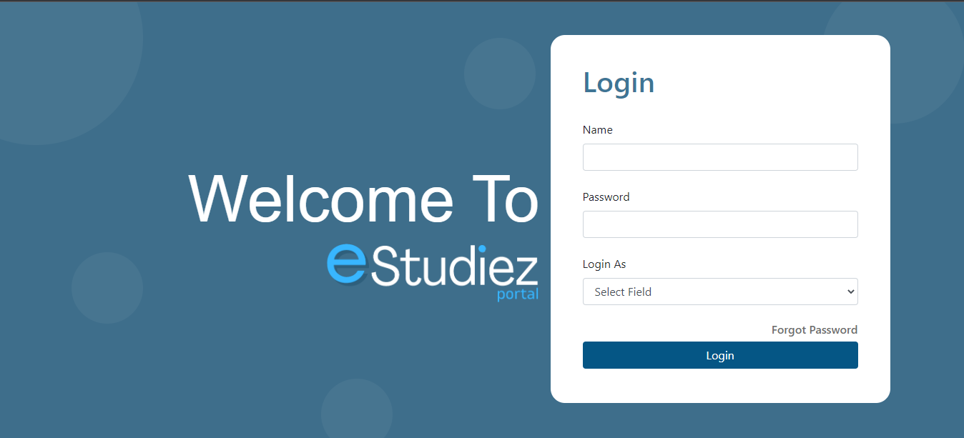

**Fields**

This website is accessible for 3 persons, Student, Teacher and Parents. There three given are option are selectable by user to login to current panel

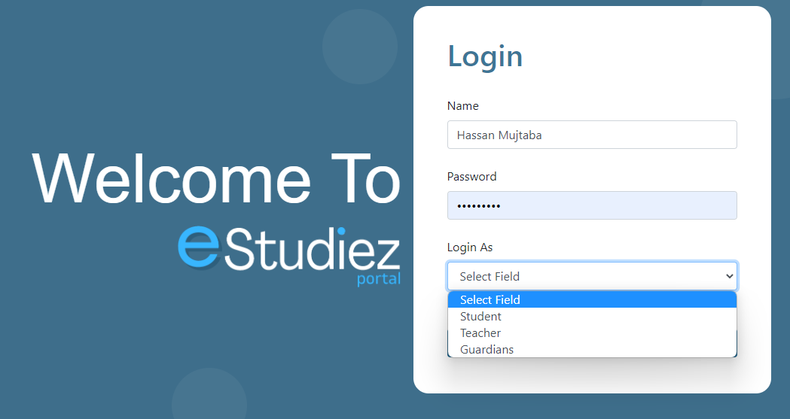

**Student Panel**

This Panel is for Students. Student can navigate to different fields as shown in figure below. Student can navigate to Grade book, Attendance, Notices, Lecture Material and many more.

There are total 6 fields listed below:

* **Grade Book**

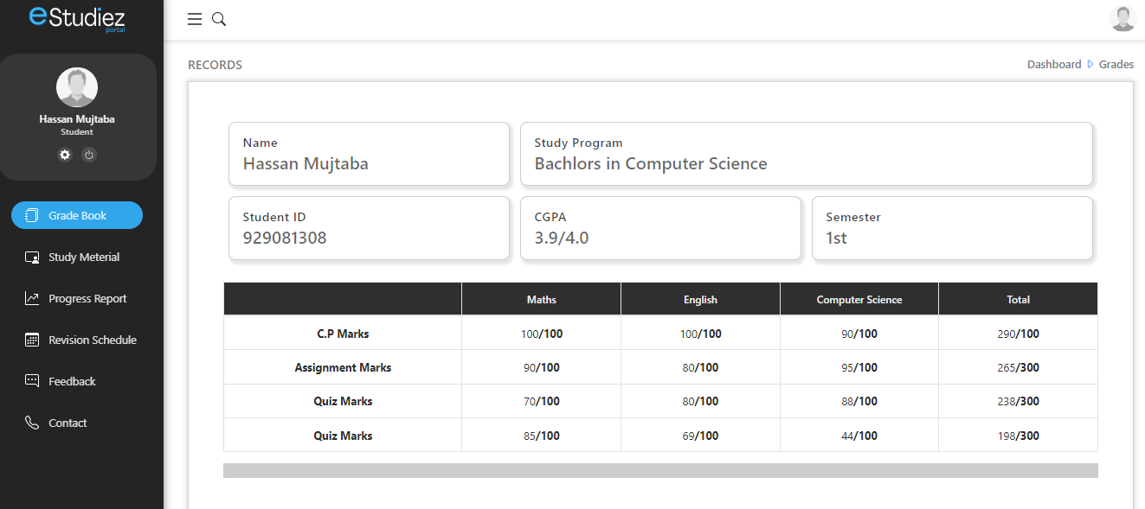

* **Study Material**

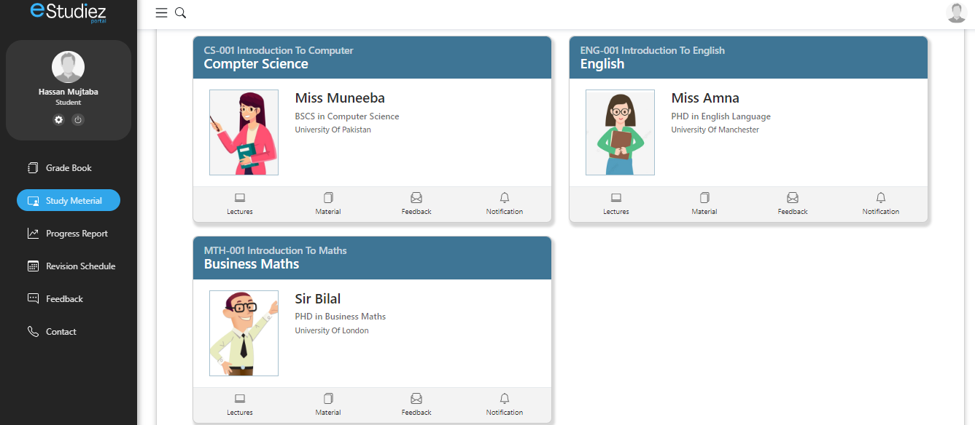

* **Progress Book**

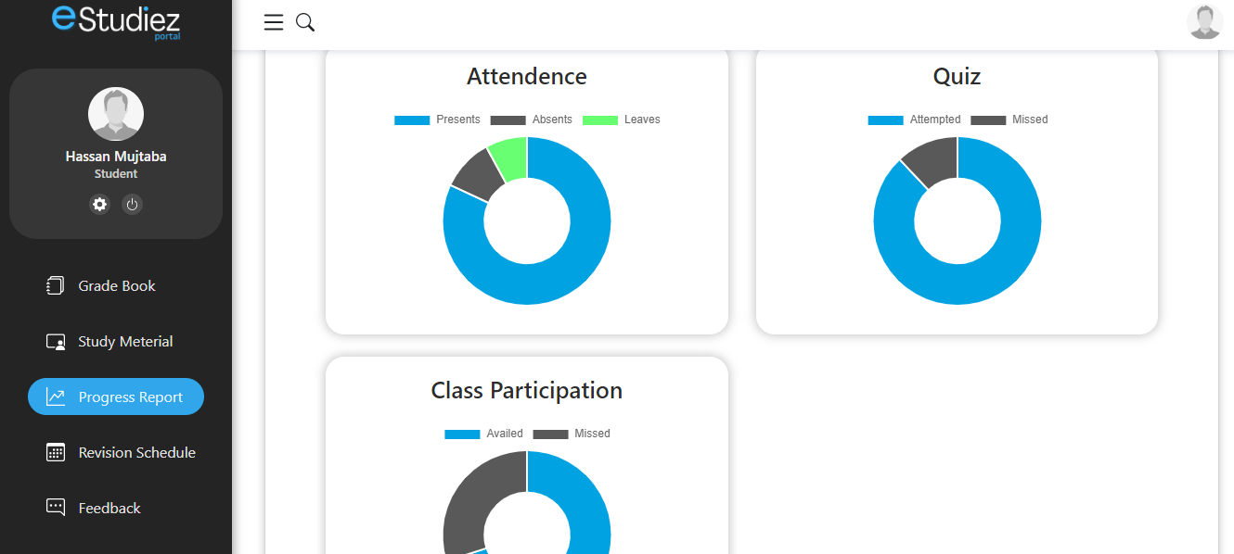

* **Revision Schedule**

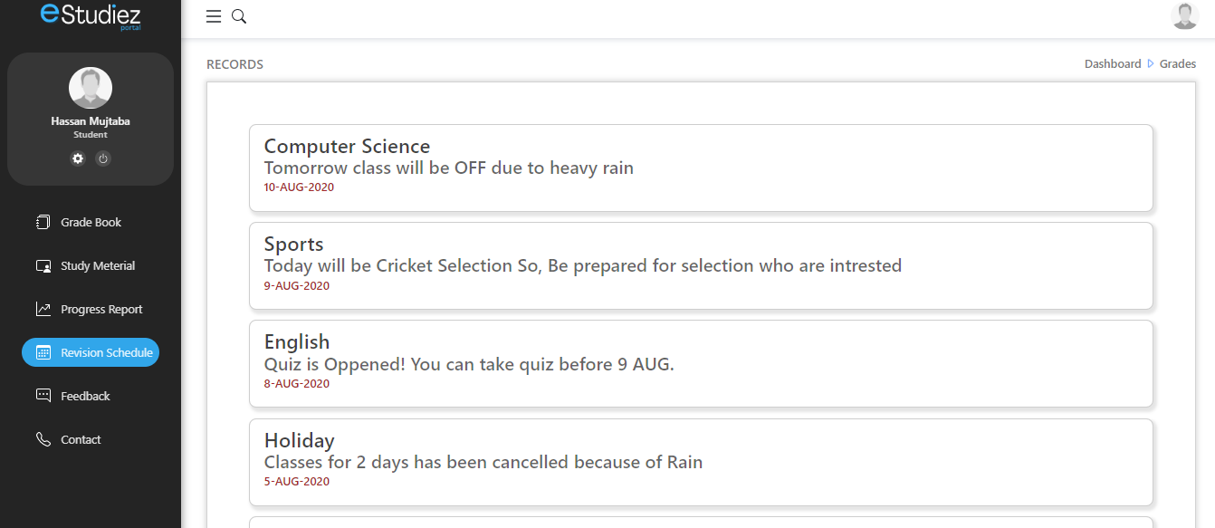

* **Feedback Form**

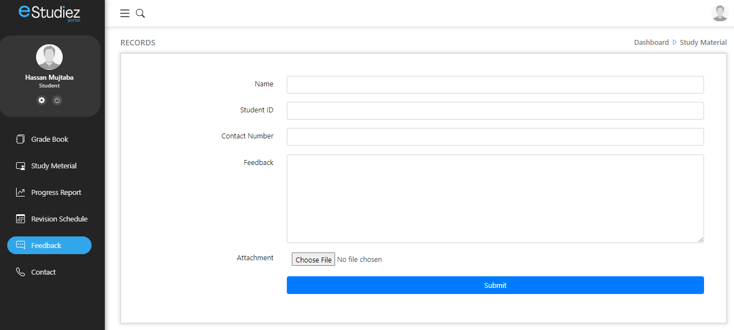

**Teacher Panel**

This Panel is for Teacher. Where Teacher can upload grades, material, Attendence and many other things. Teacher can update and delete student grades and other information.

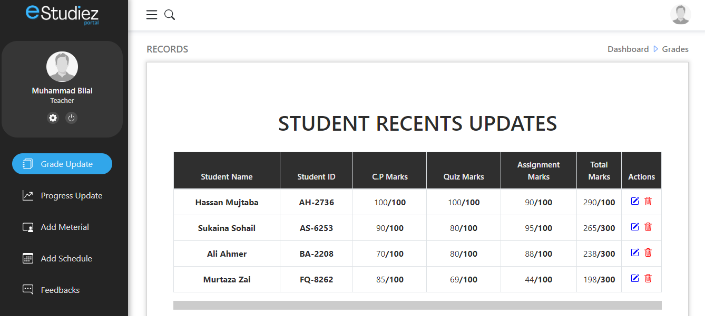

There are 6 field in this section.

* **Update Grade**



* **Add Attendence**

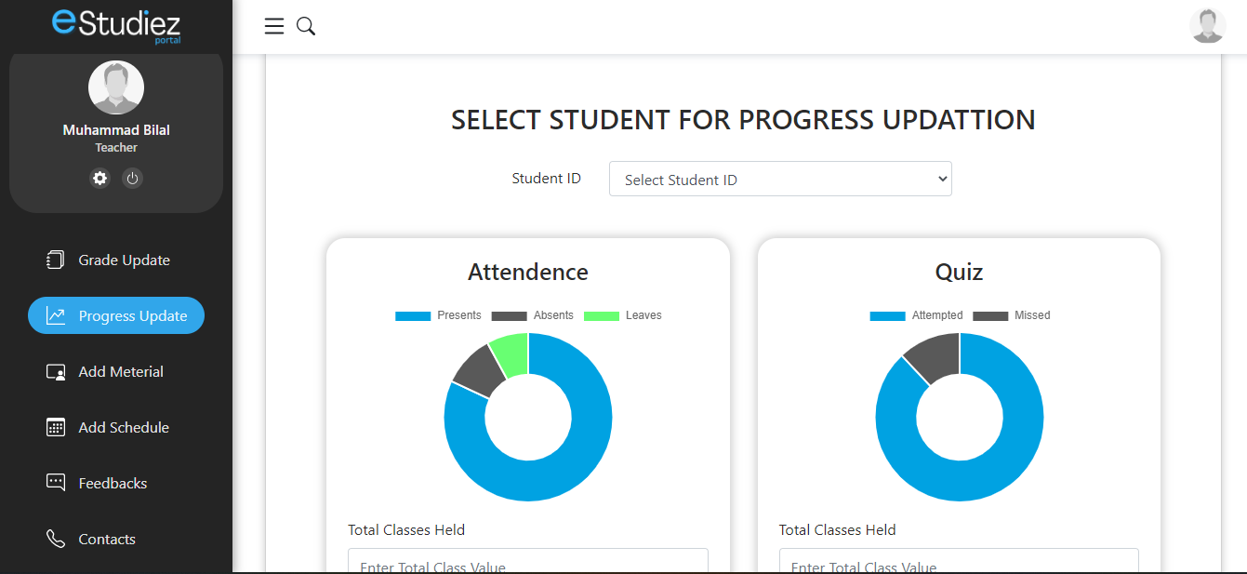

* **Add Material**

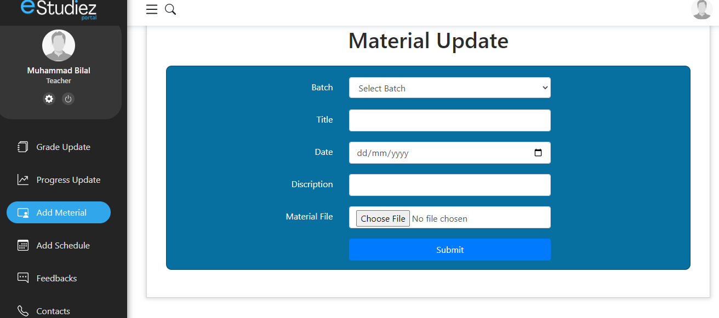

* **Feedback**

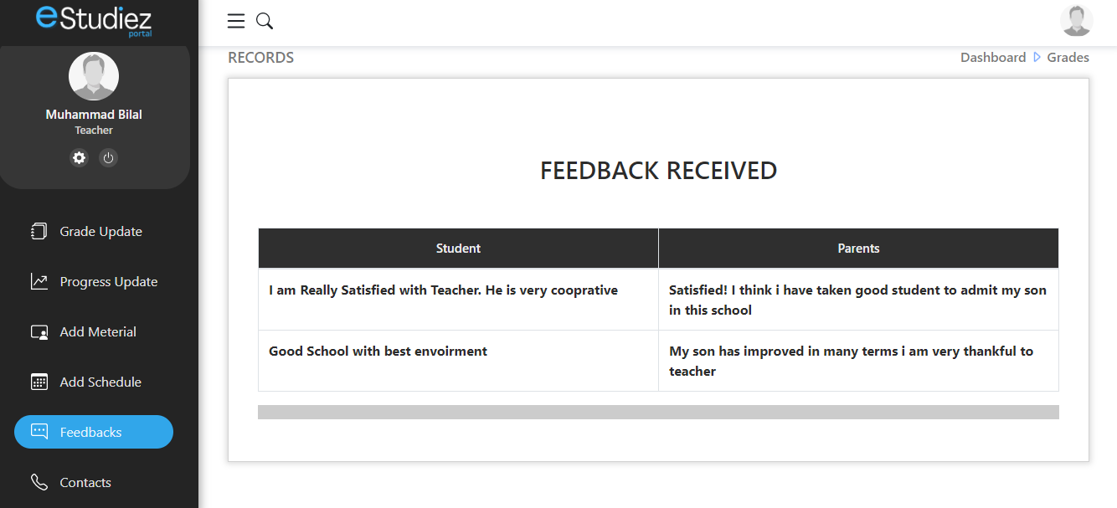

**Guardians Panel**

This panel is for parents and guardians to manage and see their sons and niece result and attendance.

Parents can see results and attendance of their kid. They can also send feedback to school or teacher.

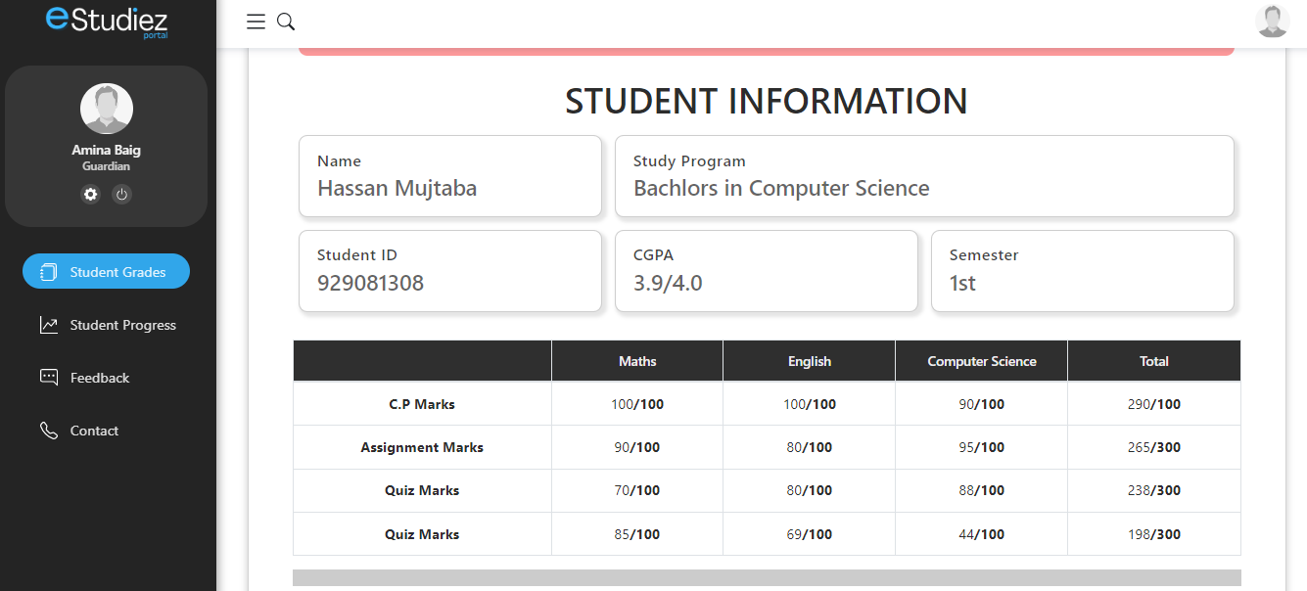

**Features**

**User can minimize sidebar according to their needs from the button in navbar.**

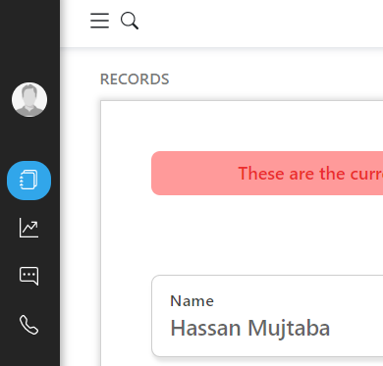

**User have 2 options to logout both are shown below**

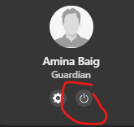

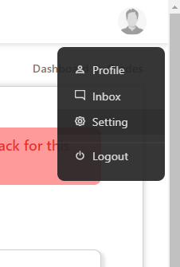

**DEVELOPMENT**

We have use JSON for data storage. We stored some student’s information like grades, Name and ID. We use this JSON data in our website in several forms. Mostly we have used this data in tables. Some of the features may be missing because of short time period but we tried our best to complete requirments.